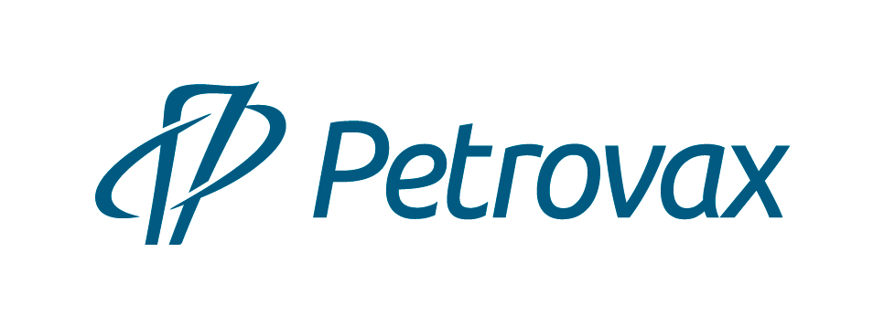

Petrovax is a Russian full-cycle biopharmaceutical company with 25 years of successful experience. The company is among the Top 5 immunobiological pharmaceutical manufacturers in Russia.
The product portfolio includes its own original pharmaceutical products and vaccines, localized medicinal products, as well as generics and dietary supplements.
The company has its own research center and investment program for the R&D field, Petrovax holds more than 20 new molecule and manufacturing process patents.
The company’s manufacturing processes fully comply with the applicable Russian and international GMP standards and ISO:9001. Petrovax’s pharmaceutical manufacturing complex located in Moscow Region is one of the most high-tech biopharmaceutical enterprises in Russia.
Petrovax capacity is more than 160 million dosages of immunobiologicals per year. Petrovax is the first Russian manufacturer of immunobiological products to pass international GMP certification from the state regulatory authorities of the EU (Slovakia) and Iran.
The company possesses expertise in implementing international projects for technology transfer for full-cycle manufacture, quality control and assurance for immunobiological drugs. Petrovax's partners are the world's leading pharmaceutical companies Pfizer, Abbott, Boehringer Ingelheim.
In 2020, Petrovax entered into an agreement with CanSino Biologics Inc., the leader of the immunobiological industry in China, for development and further production in Russia of the recombinant adenoviral vector vaccine Convidecia to prevent COVID-19 infection. In 2021, after the registration of the vaccine in the Russian Federation, Petrovax plans on manufacturing the drug at its facilities in the Moscow Region.
Petrovax is the largest Russian exporter of pharmaceuticals, including original Russian medicines to the EU. It ranks among the TOP-3 Russian pharmaceutical exporters of vaccines. The company's pharmaceutical drugs are exported to 12 countries, including the EAEU, the Middle East and the EU.

Petrovax has over 800 employees.

The company has been affiliated into the Interros Group since 2014.

Our mission: Innovative products for treatment, prevention and better quality of life.

Contact Us:
NPO Petrovax Pharm, LLC
123112, Moscow, Presnenskaya embankment, 12, Federation Tower (East), floor 38
Phone: +7 (495) 730-75-45 e-mail: info@petrovax.ru, www.petrovax.ru

